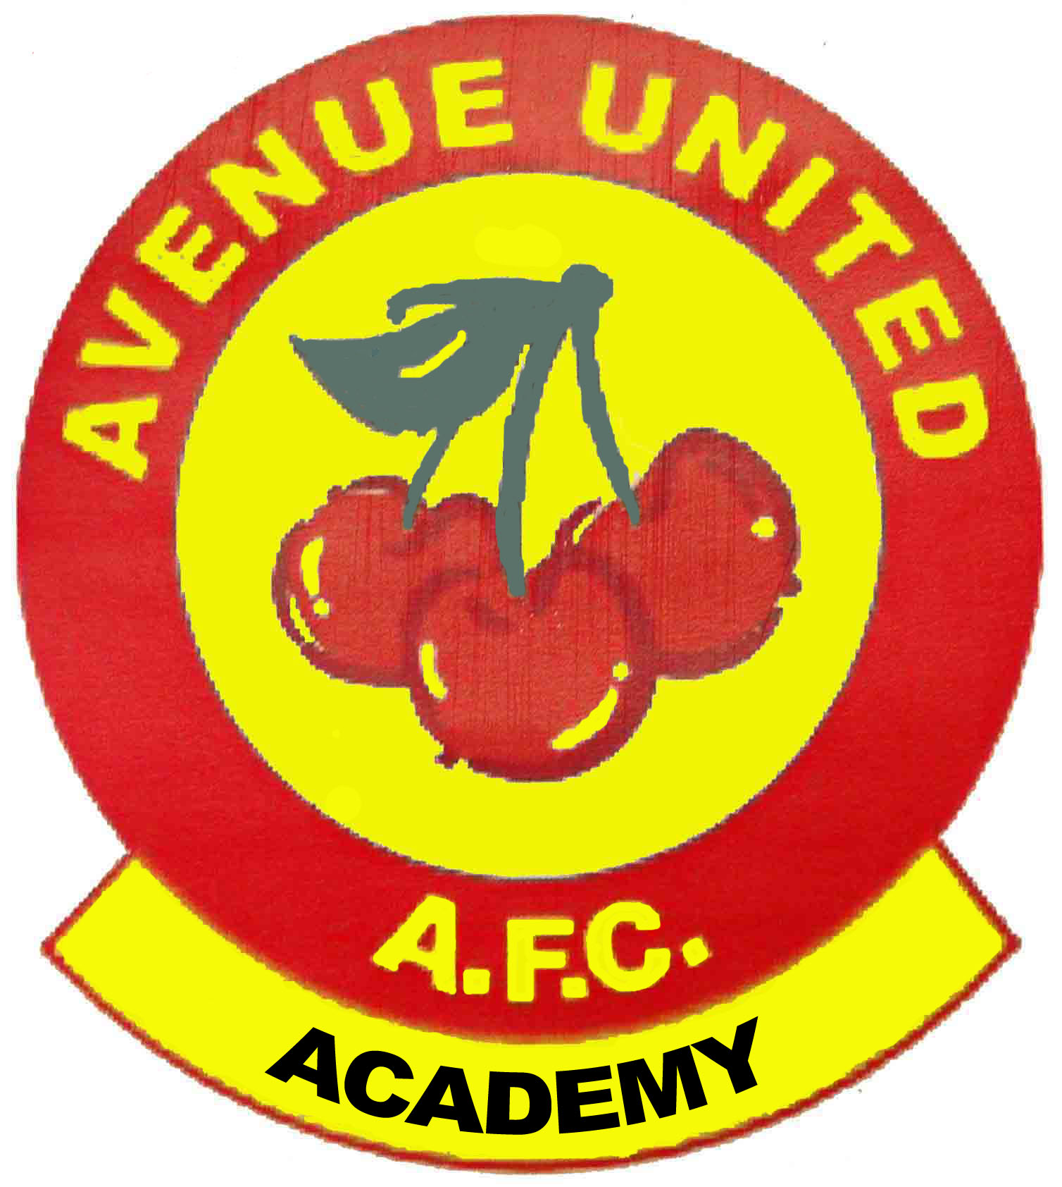
AVENUE UNITED

Academy Director : Helene Griffith
Phone : 087 8134592
Club Secretary : Nigel Bradish
Phone : 087 2873996
www.avenueunited.ie

Autumn 2015

Coaching for Boys and Girls age 5yr to 10yr… Lees Road… 2015 - 2016

Dear Parent/Guardian,
Coaching takes place from 9.30 – 10.30 each Saturday morning on the Astroturf Pitch at Lees Road. NB Weather Permitting.

Fees for this season…
- Term No. 1 … from 12th Sept until Saturday December 19th 2015… cost €60
- Term No. 2 … from Sat. Jan 9th 2016 until Sat. 14th May 2016…cost €60
2nd and subsequent children from the same family €30 per term

Please note
- A Registration Form must be completed for each child attending.
- Forms / Fees can be paid from 9.30 – 10.00 in car park.
- A texting/email service will be used to keep people informed.
- No coaching on Bank Holiday weekends.
- Coaching commences at 09.30 sharp for one hour only.
- Children should be brought down to & collected from the all-weather pitch.
- Children should wear appropriate clothing for prevailing weather conditions.
- Shin Guards and water bottles are compulsory. Football boots with plastic Studs advised and AstroTurf Velcro boots advisable.
- Blitzes will be organised throughout the season
- Children must NOT be left unsupervised before or after Coaching.
- Compulsory Training Tops / Junior Club Kits are available, contact the Director.

Please return registration form and appropriate fee at your earliest convenience.
We would appreciate your co-operation in this matter.
Remember…without the paperwork we know nothing about your child!!!

Yours in Sport,
Avenue United Academy Committee.

First name:  Block Caps Please |  | Surname:  Block Caps Please
Date of Birth:
Address:
Email Address
Parent Only | Main Mobile Contact Number
Parent Only | 2nd Mobile Contact Number
 | Home Telephone Number

MEDICAL INFORMATION
Allergies
Asthma
Diabetes
On Medication
Other
(Please include ALL information that is relevant to your child’s Health, Information treated in Confidence)

Consent by Parents
We the parents of the above named child give our consent for him/her to participate in All Avenue United Soccer Academy’s Coaching sessions, Organised Events, Blitz & Competitions etc. In the unlikely event of an Accident I/We give our permission for our child to be given immediate First Aid or taken to the nearest Hospital.
 I, the child's parent/guardian, give permission for the club to use our child's picture on their website.

Parents Signature |  | Parents Signature
Parents Name  Block Caps Please |  | Parents Name  Block Caps Please
Date: _____/_____/2009
Date: ________________________

